Lowitja O'Donoghue Foundation Nursing Scholarships 2025 Guidelines

About Lowitja O’Donoghue Foundation and Scholarships
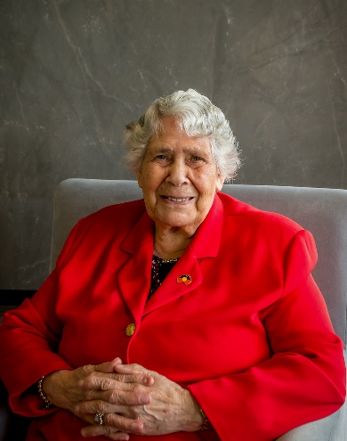
The Lowitja O’Donoghue Foundation Nursing Scholarship program is available in 2025 to Aboriginal and Torres Strait Islander students who are committed to a career in Enrolled Nursing, Registered Nursing, and Postgraduate/Higher Degree nursing (or a related discipline).

The Foundation’s scholarship program pays respect to the memory of Yankunytjatjara woman, the late Dr Lowitja O’Donoghue AC CBE DSG. Dr O’Donoghue’s extraordinary lifetime of work in Aboriginal and Torres Strait Islander health, as a trailblazer who opened doors, and kept them open, created opportunities for generations to follow in her footsteps and embrace a future of possibilities.

In 1954, Dr O’Donoghue became the first Aboriginal person permitted to train as a nurse at the Royal Adelaide Hospital in South Australia. She achieved triple certificate qualifications in nursing, midwifery, and mental health.

Lowitja O’Donoghue Foundation was established on 1 August 2022 to honour Dr Lowitja O’Donoghue’s 90th birthday.

Our purpose

We aspire to become Australia’s leading provider of Aboriginal and Torres Strait Islander-designed and delivered leadership programs, along with other transformational education opportunities, to empower the next generation of Aboriginal and Torres Strait Islander leaders to lead with and for their communities.

Dr Lowitja O’Donoghue died on 4 February 2024, aged 91 years, on Kaurna Country in Adelaide, South Australia. Please take the time to find out more about Dr Lowitja O’Donoghue


Lowitja Institute, Australia's only national Aboriginal and Torres Strait Islander community controlled health research institute, has proudly carried the name of its founding chairperson and co-patron, Dr O’Donoghue since 2010.

For over 20 years, the Institute has worked for the health of Aboriginal and Torres Strait Islander people through high-impact quality research, knowledge exchange, and by supporting a new generation of Aboriginal and Torres Strait Islander health researchers.

Lowitja Institute is dedicated to embedding cultural and social determinants into health systems across the country. We ensure our policies, research and practice is culturally safe, which contributes to closing the gap in health outcomes for our peoples.

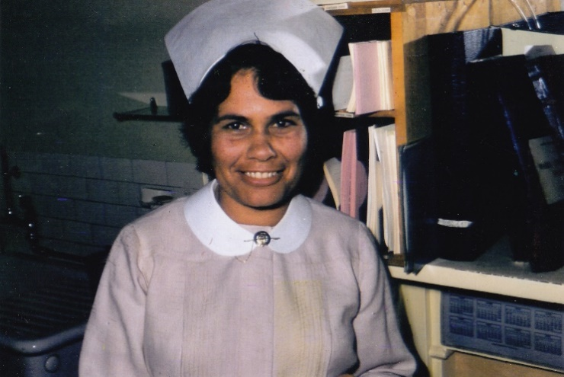
About the Nursing Scholarship Program

For 2025, the Lowitja O’Donoghue Foundation Nursing Scholarship Program is excited to announce three targeted scholarship streams to support aspiring and current nurses in advancing their qualifications in nursing. The streams are Vocational Education and Training (VET), Undergraduate, and Postgraduate/Higher Degree.

The purpose of the program is to impact Aboriginal and Torres Strait Islander health and wellbeing priorities, and to support and contribute to the growth of the Aboriginal and Torres Strait Islander nursing workforce in Australia.

The Lowitja O’Donoghue Foundation Nursing Scholarship Program offers these three streams:

VET/ Diploma Nursing Scholarship (Enrolled Nurse)
Value: Up to $22,500
Duration: Up to a maximum of 18 months of full-time study

Undergraduate Bachelor of Nursing Scholarship (Registered Nurse)
Value: Up to $45,000
Duration: Up to a maximum of three years of full-time study

Postgraduate/Higher Degree Nursing Scholarship (Masters, PhD, or related discipline)
Value: Up to $40,000
Duration: Up to a maximum of two years of full-time study

Guidelines and how to apply

Stream 1
VET/ Diploma Nursing (Enrolled Nursing)
- Refer to the linked Conditions of Award
- Apply online via the Smarty Grants platform [add link]

Stream 1
Undergraduate Bachelor of Nursing (Registered Nursing)
- Refer to the linked Conditions of Award
- Apply online via the SmartyGrants platform [add link]

Stream 3
Postgraduate/Higher Degree Nursing (Masters, PhD, or related discipline)
- Refer to the linked Conditions of Award
- Apply online via the SmartyGrants platform [add link]

Scholarship round timeline (*all streams)
Round opens | Friday 29 November 2024
Round closes | Monday 20 January 2025
Assessment review | w/c Monday 3 February 2025
Scholarships awarded | Late March 2025
Application process
Applications must be submitted via the Smarty Grants online platform
(see specific links below under individual streams)

Contact us

For all enquiries regarding the application process, please contact foundationscholarships@lowitja.org.au

Lowitja O’Donoghue Foundation Nursing Scholarship Program is funded by the Australian Government.

